Quantum Circuit Born Machine Assisted Fraud Detection
in Financial Transactions
Final report
By: Maryam Taoumi
Supervised By: Dr. Fouad Mohammed Abbou
12/09/2025

1. Project Overview
This report explains the work I did to build and test a quantum model a Quantum Circuit Born Machine (QCBM) for anomaly detection in financial transactions.
The main goal was to learn the pattern of normal transactions and then detect anything that looks different.
I tested two main approaches:
- PCA + QCBM
- VAE + QCBM
Both methods create a 2-dimensional representation of the data, which is then used to train the QCBM.
The report covers preprocessing, analysis, model architecture, experiments, results, and conclusions.

2. Dataset Preparation
The dataset contains about 284,807 transactions, including only 492 fraud cases. Since fraud is extremely rare, anomaly detection is difficult.
2.1 Cleaning and Transformations
- Applied a log transform on the “Amount” column to reduce skewness
- Normalized all features
- Used PCA to reduce 29 features to 2 dimensions
2.2 PCA Normalization and Binning
After PCA, I scaled the two PCA components to $\left[0 , 1\right]$.
Then I divided this 2D PCA space into a 16×16 grid, giving 256 bins.
This size matches an 8-qubit QCBM, which outputs 256 possible states.

3. PCA Analysis
Full Dataset Behavior
In the full dataset, fraud and normal transactions almost overlap completely.
Because of this overlap, PCA does not separate the data well, and anomaly detection becomes very difficult.
Small Dataset Behavior
With a smaller sample (around 1,000 points):
- Fraud becomes more separated
- PCA produces clearer clusters
- QCBM performs extremely well in this case
This helped explain why results were good for small datasets but not for the full set.

4. QCBM Architecture
The QCBM model I used is an 8-qubit, 8-layer quantum circuit.
Each layer contains:
- Ry rotation gates (trainable parameters)
- Circular CNOT entanglement (connects qubits in a loop)
Total parameters: 64 trainable weights
Output states: 256 outcomes (2⁸) → matches the 16×16 PCA grid
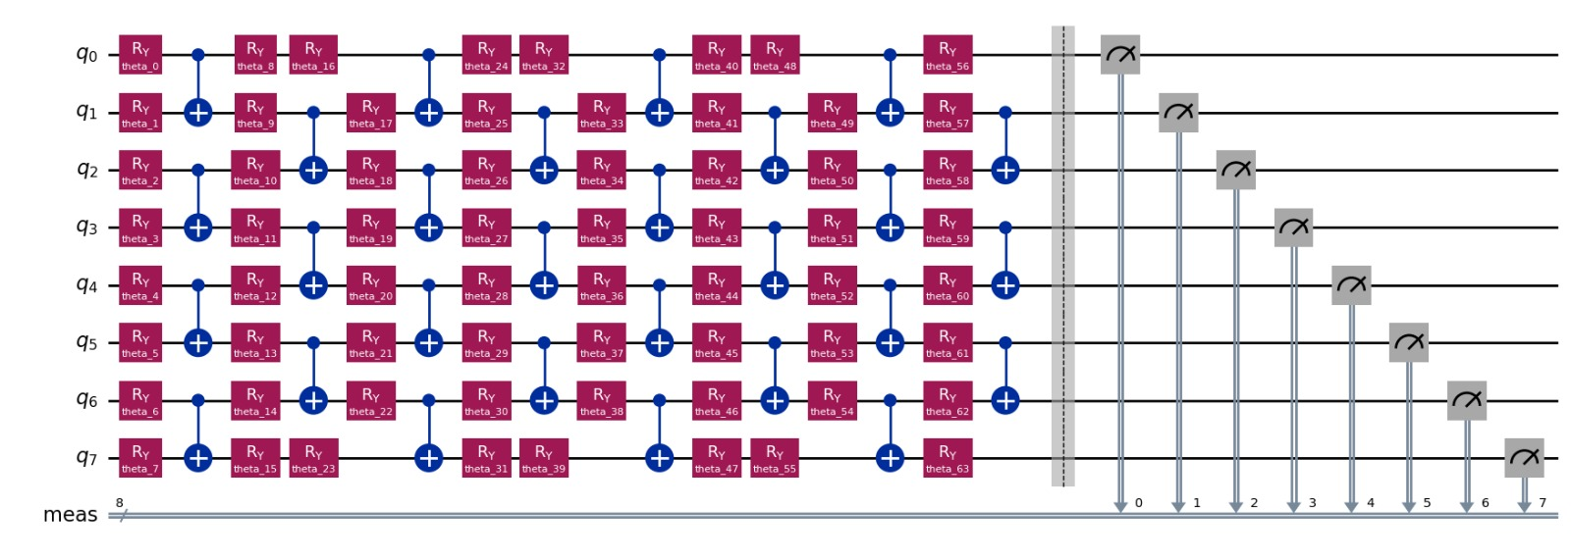Figure 4 QCBM Circuit Diagram

5. Code Snippets (Implementation)
Below are the key parts of the implementation that show how the model was built.

5.1 Actual VAE Model
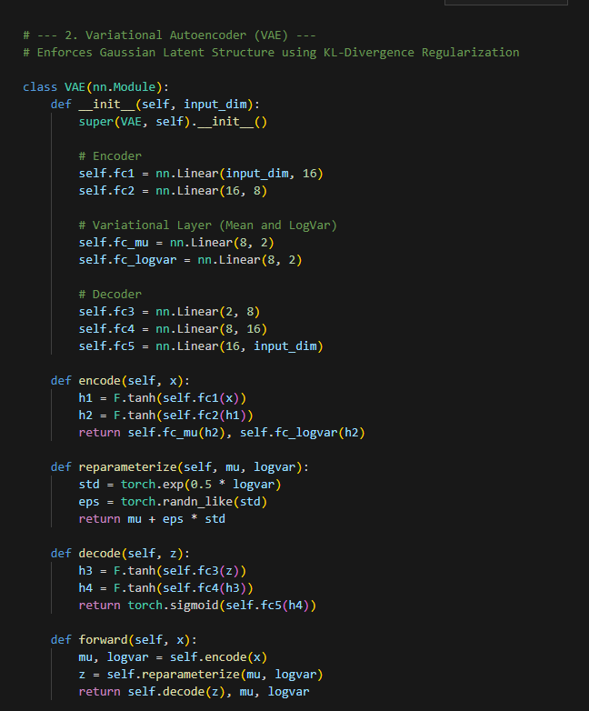

5.2 VAE Training Loop
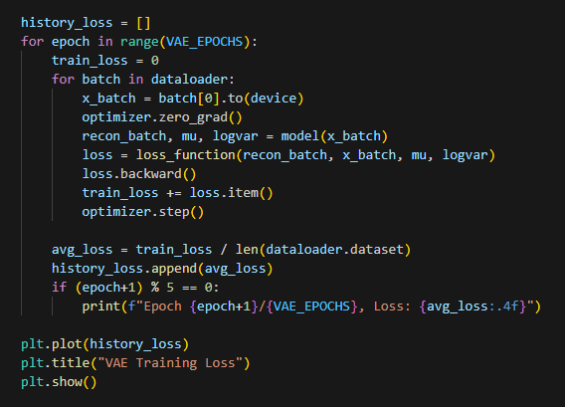
5.3 Hybrid QCBM Evaluation
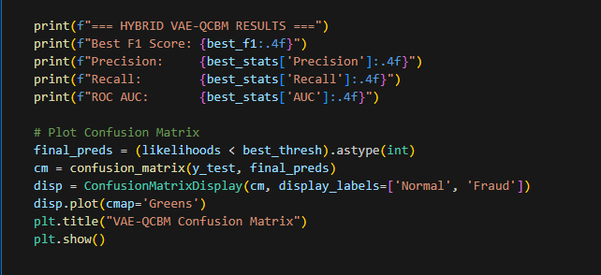

6. QCBM Learning Process
The QCBM tries to learn the probability distribution of normal transactions.
6.1 Target Distribution
We build a 16×16 heatmap showing where normal transactions fall.
6.2 Before Training
The QCBM output is random and does not match the target distribution.
6.3 After Training
The QCBM’s learned distribution becomes much closer to the target.
The cost function decreases, showing successful learning.

7. QCBM Results on PCA Space
Small Dataset Results
- Very good performance
- Fraud is detected easily
- Confusion matrix shows high accuracy
Full Dataset Results
- QCBM struggles
- Fraud and normal overlap heavily
- Likelihood scores are too similar
- Thresholding does not separate the two classes

8. VAE–QCBM Hybrid Approach
Since PCA did not fully separate fraud, I tried a VAE to learn a better representation.
8.1 VAE Training
The VAE was trained only on normal data.
Reconstruction loss dropped quickly → the VAE learned the structure well.
8.2 Latent Space Behavior
Even after non-linear compression:
- Fraud still overlaps normal points
- Separation is still limited
8.3 QCBM on the Latent Space
The QCBM learns the latent distribution, but:
- Fraud is still misclassified
- The overlap problem remains

9. Discussion
Here are the main insights from the experiments:
1. QCBM performs well only when the data is separable
In small datasets, PCA separates fraud nicely → QCBM performs extremely well.
2. Full dataset PCA shows strong overlap
Fraud looks too similar to normal, so models fail.
3. VAE helps, but not enough
Latent space is cleaner, but fraud still overlaps.
4. The bottleneck is the representation, not the QCBM
The quantum model learns distributions well, but it cannot separate classes that are mixed in the input space.

10. Limitations
Some important limitations:
- Fraud is extremely rare
- PCA loses some useful structure
- VAE does not fully isolate anomalies
- QCBM limited to 8 qubits due to simulation constraints
- Training quantum models is computationally expensive

11. Conclusion
The QCBM is able to learn the normal distribution very well and performs strongly when the data representation separates fraud from normal.
However, on the full dataset, where fraud overlaps a lot with normal transactions, the QCBM struggles to detect anomalies.
The main challenge is feature representation, not the quantum circuit.
Future work:
- Better feature extraction
- More advanced quantum encoding
- Larger circuits
- Hybrid classical–quantum systems
- Testing on real quantum hardware

